
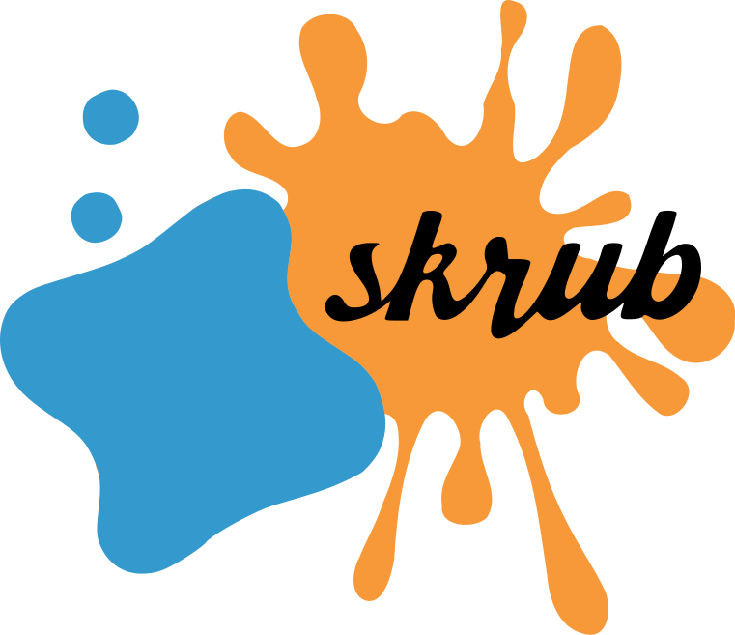
skrub: prepping tables for machine learning
Deduplicating
TableVectorizer
Encoding
Joining a pool of tables
Joining two tables
MinHashEncoder
GapEncoder
Assembling

References

Jovan Stojanovic and Lilian Boulard*
Inria Saclay, Soda team, France
*Presenting authors | E-mail: {first name}.{last name}@inria.fr
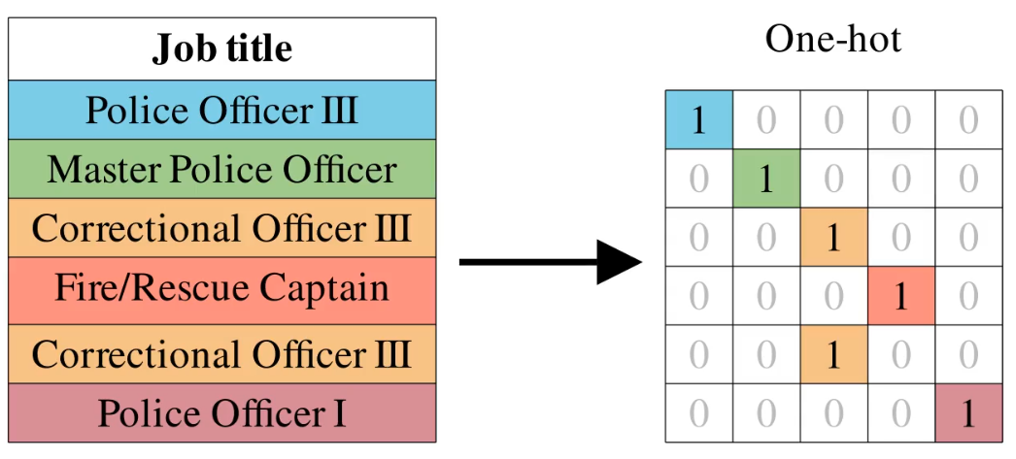
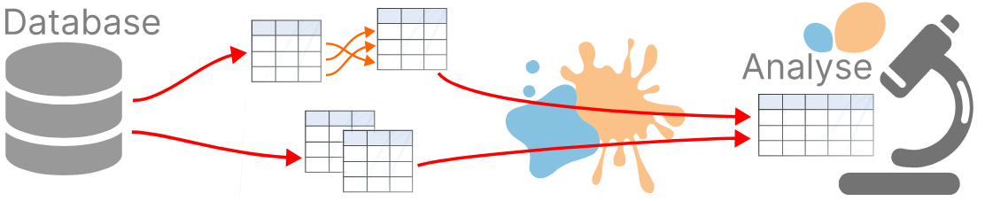
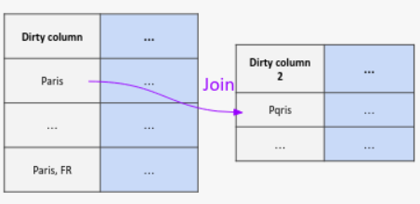
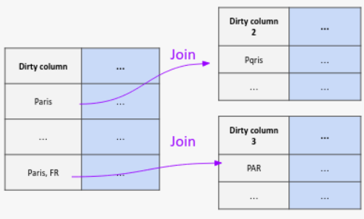
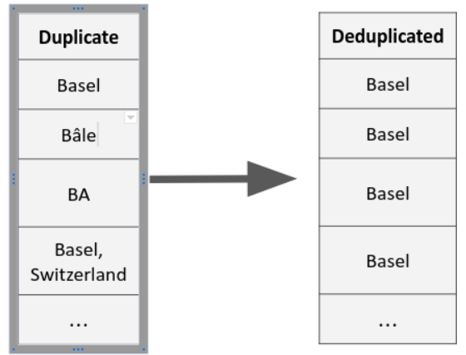
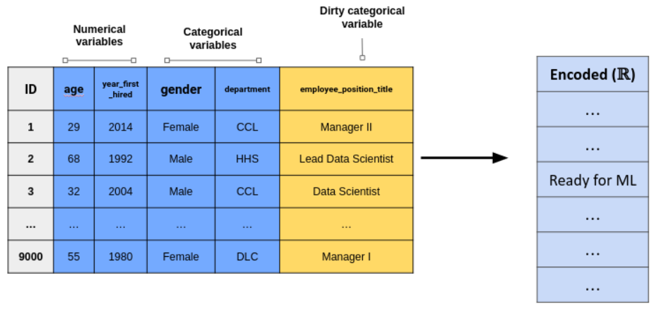
[1] Patricio Cerda, Gaël Varoquaux, Balázs Kégl. Similarity encoding for learning with dirty categorical variables. Machine Learning, Springer Verlag, 2018, 10.1007/s10994-018-5724-2. hal-01806175

[2] Patricio Cerda, Gaël Varoquaux. Encoding high-cardinality string categorical variables. 2019. hal-02171256v4
> X = TableVectorizer().fit_transform(df)
- One line of code - automatic encoding.
- Encoders chosen based on heuristics, but can also be customized.
- Replacement for the ColumnTransformer.
Describes each sample as a linear combination of latent categories (topics). Interpretable output. [2]
> fuzzy_join(df1, df2, left_on, right_on)
> joiner = Joiner([(df2, “col2”),
(df3, ”col3”)...], main_key=“col1”)
> joiner.fit_transform(df1)
- Fuzzy joining of dirty tables.
- Works on numerical, datetime, string or mixed types.
- Works on multiple join keys.
- Multiple tables transformer.
- Scikit-learn compatible.

Encoding: transform dataframes into numerical arrays ready for machine learning.
Classical methods (One-hot encoding…) need clean data, as they encode each unique value independently.
They fail to capture morphological similarities (variations or typos), which often have meaning.
- skrub encoders propose new, adapted methods. [1]
Based on hierarchical clustering.
> deduplicate()
Very fast, stateless (for parallel encoding).
Based on hashing functions (min-hash of sub-strings). [2]

